Brayford Studio Lincolnshire 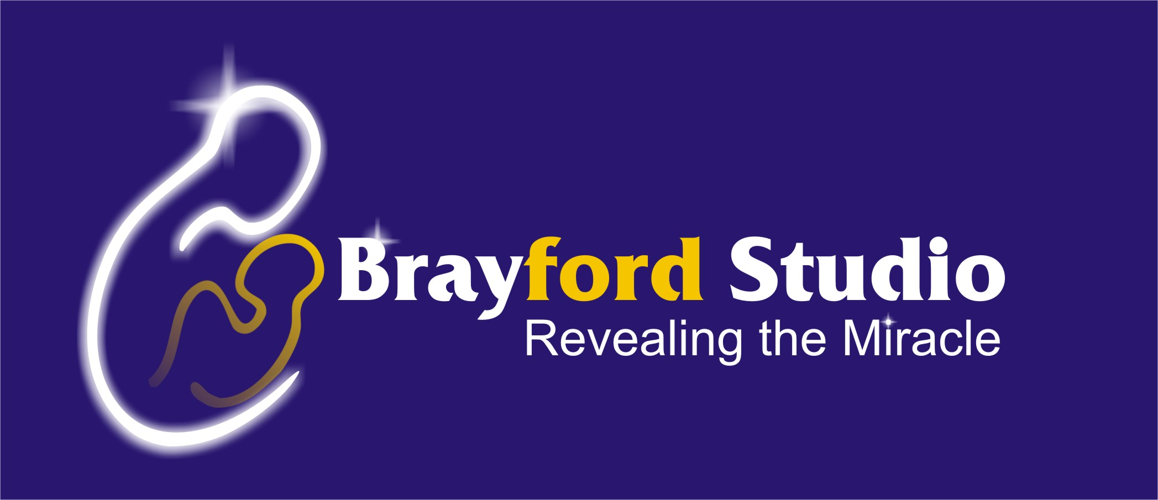
Ultrasound Scan Booking Form
Brayford Total Obstetric Ultrasound Care
Lincoln
Date:

Surname: Forenames
DOB Partner’s forename

Address

Tel: Post code
Home Work Mobile

Email Address

Clinical Details:--
No. of pregnancies: No. of children:
Any vaginal Bleeding, Pain or other Problems in current pregnancy

LMP (Last Menstrual Period):
EDD (Expected Date of Delivery): No. of Weeks now

Brayford Total Obstetric Ultrasound Care: Total Price : £599.99

This Includes:-
1- Pregnancy Dating Scan,2D 06 -10 weeks
2- Nuchal &Nasal bone scan for Down’s Syndrome 2D 11 -13 weeks
3- Reassurance scan with or without Gender 16 -18 weeks
4- Anomalies scan at 2D 20 -22 weeks
5- 3/4D Scan, this includes: 2D wellbeing scan, DVD&CD 29- 32 weeks
6- Fetal Wellbeing & Growth scan2D scan at 34- 38 weeks
7- Scans at any other time carries Extra charges. 06 -42 weeks

Instalments:
1st Instalment Payable at Booking & First scan £264.99
2nd Instalment Payable at 22 weeks scan £235.00
3rd Instalment Payable at 29 weeks scan £100.00
Different payment arrangements are also available on request. Please ring for details
GP: Name Address Tel
Post code

How did you know about the Brayford Studio?
Internet, magazines or newspapers, etc.…….

Please REMOVE any abdominal piercing prior to your scan

Signature………………………………………………………...

Payment Details:
Payment can be made either by cash or by credit cards.
Cheques are no longer accepted. Thank you

